**HOME**

Hi-Tech Wires Asia CO., Ltd. or simply known as HWA is a subsidiary of Thermo technologies Group and is the only manufacturing facility of the group in Asia. It starts the operation in the end of 2007. As a worldwide leader in the supply of wire for electric discharge machining (EDM), HWA offers a wide range of high performance EDM wire that enable industrial companies in the fields of precision mechanics to improve their productivity by optimizing speed and cut precision. Other than that, HWA is also manufacturing Special wires (high technology solid and stranded wires) and Diamond wires.

HWA is located in the heart of beautiful city namely SAIGON or Ho Chi Minh City. The location of the factory is at Vietnam-Industrial Park (VSIP) 1 in Binh Duong province which is only 30km from Saigon Port and 22km from Tan Son Nhat international Airport.

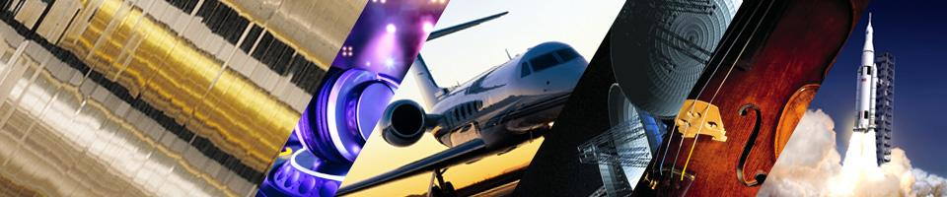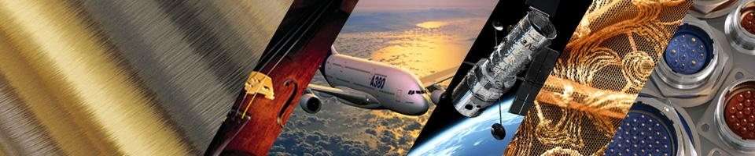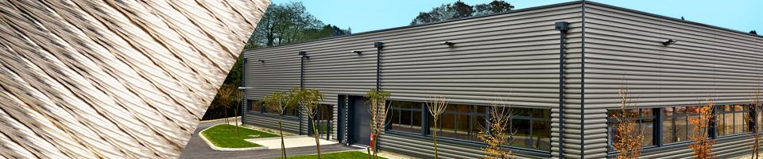

SPECIAL WIRES

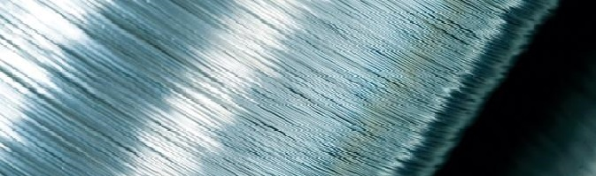

DIAMOND WIRES

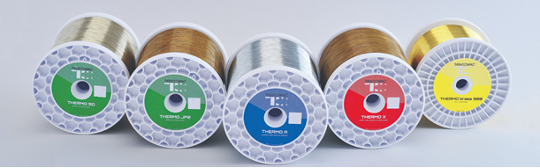

EDM WIRES

Link

Link

Link

**EDM WIRE - Products**

As a worldwide leader in the supply of wire for electro discharge machining (EDM) , HWA offers a wide range of high performance EDM wire that enable industrial companies in the fields of precision mechanics to improve their productivity by optimizing speed and cut precision.

HWA has been present in this market since 2007 and has been since manufacturing high technology EDM wires for the customers especially in Asian region with the mind of keeping low cost and high quality products. The engineers in HWA is always striving to maintain an excellent manufacturing process, thus maximizing the yield and improving product quality.All this is to ensure that customer will recieve excellent product which gain additional speed performance and cut precision in order to improve productivity.

HWA as a manufacturing facilities in Vietnam is a subsidiary of Thermo Technologies Group, are exporting to more than 20 countries.

|  |  |
| --- | --- |
| * Stratified Wire | VERY HIGH SPEED & PRECISION |
| * CopperZinc & special coating | SPEED & PRECISION |
| * Brass + Zinc coating | SUPER PRECISION & SPEED |
| * Brass + Zinc Wire | ALL PURPOSE |

# SPECIAL WIRES - Products

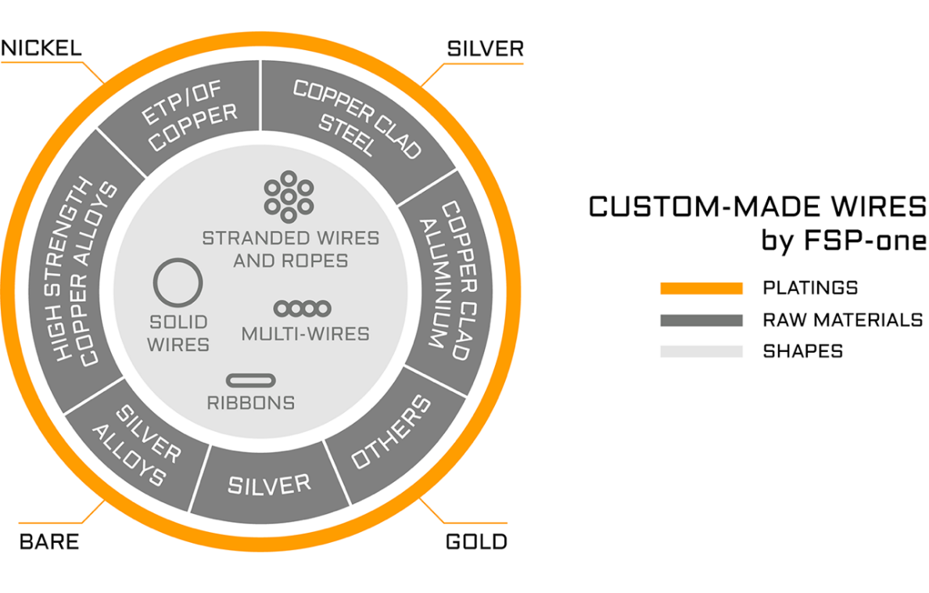

HWA is specialized in manufacturing and sale of high technology solid wire and stranded wire under the strict manufacturing process control from FSP One.

HWA products are a combination of copper or precious metals cores plated with another metal, such as silver-plated copper, nickel-plated copper or gold-plated copper with different shapes.

# PLATINGS:

SILVER PLATED

Link

NICKEL PLATED

Link

# TECHNICAL INFO:

REELS/BOBBINS

Link

STANDARD SIZE

Link

# Markets

FSP-one supplies several markets that have very high quality requirements, thanks to its long experience in gold plated, silver plated, nickel plated, solid wire and stranded wire.

* **Cable industry**Aerospace, commercial and military aircraft, computers, telecommunications, medical, automotive, geophysical, high temperature cables
* **Components**Fuses, connectors, electronics

# DIAMOND WIRES - Products

HWA offers **newest fixed abrasive highly technical engineered wires.**

Diamond wires by HWA are the result of :

* A century of technological know-how and innovation in electroplating
* The R&D’s team dynamic and proven approach of research and progress

To reach the goals of technical and improved productivity of our customers, we apply our founding values since 1913 :

* **EXPERTISE**
* **EXCELLENCE**
* **INNOVATION**

We offer a COMPLETE TECHNICAL and LONG TERM SUPPORT FOR the COMPETITIVE NEEDS of our customers, including personalised recommendations.

Diamond wires by HWA are tailor made for specifications and/or technical requirements of our clients, and dedicated to their needs :

**PRINTABLE TECHNICAL DOCUMENTS :**



Link

# JOB OFFERS – HWA

We are an important key player in industry on its international high-tech markets: high end wires for EDM, specialty coated wires (solid and stranded wires), diamond electroplated wires.

We are a growing group, focusing on employee well-being.

### WE OFFER:

* Job training program with recognized institutions
* Development and career advancement opportunities
* Challenges worthy of your expertise and your ambitions
* Our employees work in a collaborative working environment.

# 

# POSITIONS CURRENTLY AVAILABLE IN HWA;

None at this moment.

**EDM WIRE - Contact**

|  |  |
| --- | --- |
| **http://localhost/hitechwiresasia.com/images/Media-HWA/logo%20HWA%2020pct.jpg**  **Vietnam, Factory HI-TECH WIRES ASIA CO., LTD**  46, Road No. 6, VSIP 1, Thuan An, Binh Duong Province Vietnam. [sales@hitechwiresasia.com](mailto:sales@hitechwiresasia.com) Tel +84 (0) 650 3769 131 ext 103 | **China, Sales office**  FSP-one SAS Sales Representative Office Shanghai, PRC [yyan@fsp-one.com](mailto:tgwee@thermocompact.com) Tel +86 21 6351 2950 |
| **SINGAPORE, Office**  134 Jurong Gateway Road #03-309G Singapore 600134 [tgwee@thermocompact.com](mailto:tgwee@thermocompact.com) Tel +65-65649959 | **USA, Office**  FSP-one Inc. 157 Grove St. Suite 80 Franklin, MA 02038 USA [jguzik@fsp-one.com](mailto:jguzik@fsp-one.com) Tel +1 508 553 3905 |
| **http://localhost/hitechwiresasia.com/images/Media-HWA/download.png**  **Headquarters THERMOCOMPACT – Fils EDM**  Z.I. « Les Iles » - 181 route des Sarves CS 70021 METZ TESSY F – 74371 PRINGY Cedex [edm-wires@thermocompact.com](mailto:edm-wires@thermocompact.com)Tel +33 (0)4 50 27 20 02 | **http://localhost/hitechwiresasia.com/images/Media-HWA/logo.png**  **Headquarters FSP One SAS**  FSP-One SAS 38230 Pont-de-Chéruy France [sales@fsp-one.com](mailto:edm-wires@thermocompact.com)Tel +33 (0)4 78 32 39 39 |